**POLLSTER PROJECT**

G:\ >mkdir POLLSTER_PROJECT

G:\ >cd POLLSTER_PROJECT

G:\POLLSTER_PROJECT>pipenv shell

(POLLSTER_PROJECT-IcR9QnOD) G:\POLLSTER_PROJECT>pipenv install django

(POLLSTER_PROJECT-IcR9QnOD) G:\POLLSTER_PROJECT>django-admin startproject pollster

(POLLSTER_PROJECT-IcR9QnOD) G:\POLLSTER_PROJECT>cd pollster

(POLLSTER_PROJECT-IcR9QnOD) G:\POLLSTER_PROJECT\pollster>python manage.py runserver

(POLLSTER_PROJECT-IcR9QnOD) G:\POLLSTER_PROJECT\pollster>python manage.py migrate

(POLLSTER_PROJECT-IcR9QnOD) G:\POLLSTER_PROJECT\pollster>python manage.py startapp polls

**Polls/models.py**

from django.db import models

class Question(models.Model):

    question_text = models.CharField(max_length=200)

    pub_date = models.DateTimeField('date published')

    def __str__(self):

        return self.question_text

class Choice(models.Model):

    question = models.ForeignKey(Question, on_delete=models.CASCADE)

    choice_text = models.CharField(max_length=200)

    votes = models.IntegerField(default=0)

    def __str__(self):

        return self.choice_text

**question = models.ForeignKey(Question, on_delete=models.CASCADE)**

**This will create foreignkey for Question Table**

**on_delete=models.CASCADE => If question is deleted then choice is also automatically deleted**

* If we create onle class and fields in admin we will get object so

def __str__(self):

        return self.choice_text

This will give us Choice Text In admin dashboard

**pollster/settings.py**

INSTALLED_APPS = [

    'polls.apps.PollsConfig',

]

(POLLSTER_PROJECT-IcR9QnOD) G:\POLLSTER_PROJECT\pollster>python manage.py makemigrations polls

(POLLSTER_PROJECT-IcR9QnOD) G:\POLLSTER_PROJECT\pollster>python manage.py migrate

(POLLSTER_PROJECT-IcR9QnOD) G:\POLLSTER_PROJECT\pollster>python manage.py shell (InteractiveConsole)

>>> from polls.models import Question, Choice

>>> Question.objects.all()

<QuerySet []>

>>> from django.utils import timezone

>>> q=Question(question_text='What is your favorite Python Framework?', pub_date=timezone.now())

>>> q.save()

>>> q.question_text

'What is your favorite Python Framework?'

>>> Question.objects.all()

<QuerySet [<Question: What is your favorite Python Framework?>]>

>>> Question.objects.filter(id=1)

<QuerySet [<Question: What is your favorite Python Framework?>]>

=>This gives list in an array

>>> Question.objects.get(pk=1)

<Question: What is your favorite Python Framework?>

=>This gives us a single question

>>> q = Question.objects.get(pk=1)

>>> q.choice_set.all()

<QuerySet []>

>>> q.choice_set.create(choice_text="Django", votes=0)

<Choice: Django>

>>> q.choice_set.create(choice_text="Flask", votes=0)

<Choice: Flask>

>>> q.choice_set.create(choice_text="Web2py", votes=0)

<Choice: Web2py>

>>> q.choice_set.all()

<QuerySet [<Choice: Django>, <Choice: Flask>, <Choice: Web2py>]>

>>> quit()

(POLLSTER_PROJECT-IcR9QnOD) G:\POLLSTER_PROJECT\pollster>python manage.py createsuperuser

Username (leave blank to use 'smile'): oxus

Email address: oxus@gmail.com

Password:oxus

Password (again): oxus

Superuser created successfully.

<http://127.0.0.1:8000/admin/>

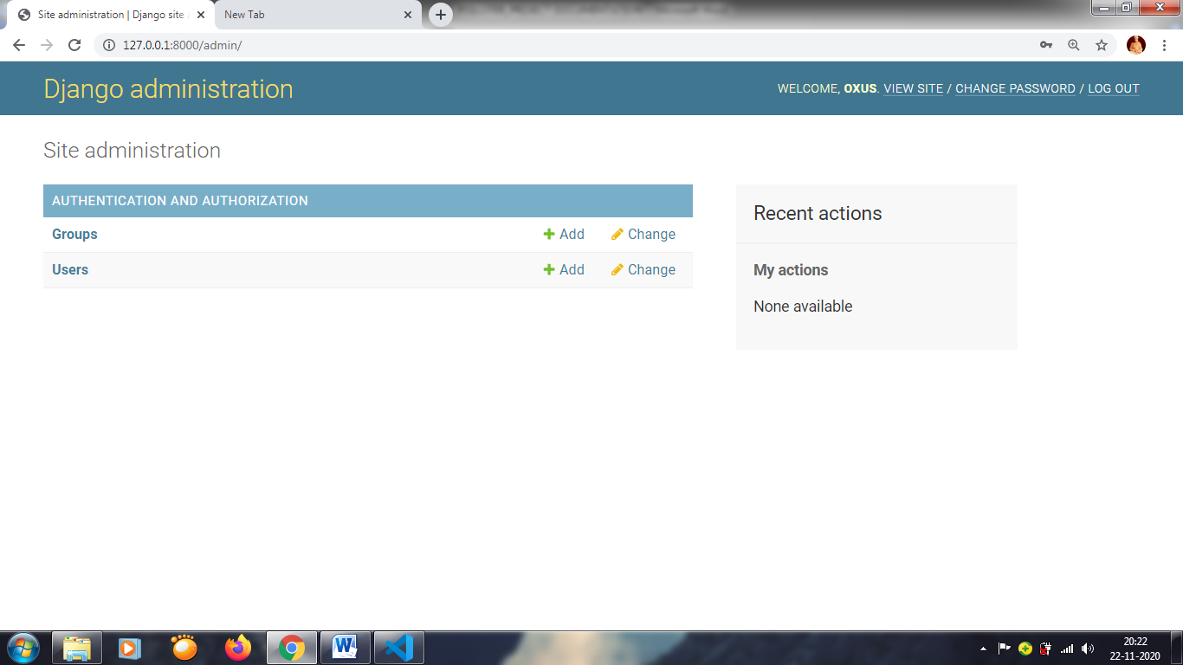

**Polls/admin.py**

from django.contrib import admin

from .models import Question, Choice

admin.site.register(Question)

admin.site.register(Choice)

<http://127.0.0.1:8000/admin/>

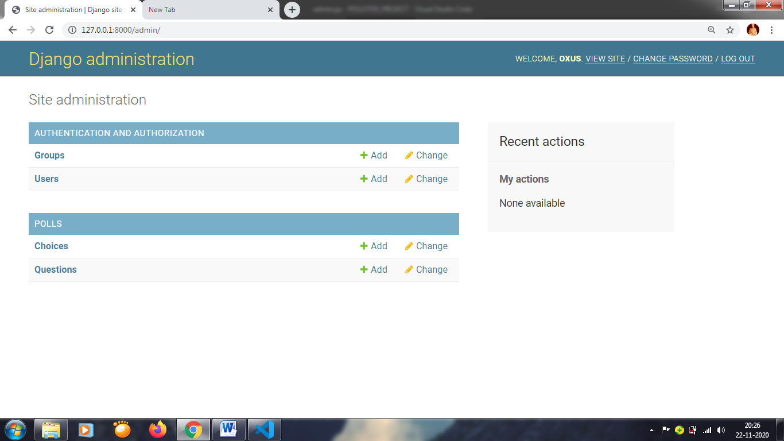

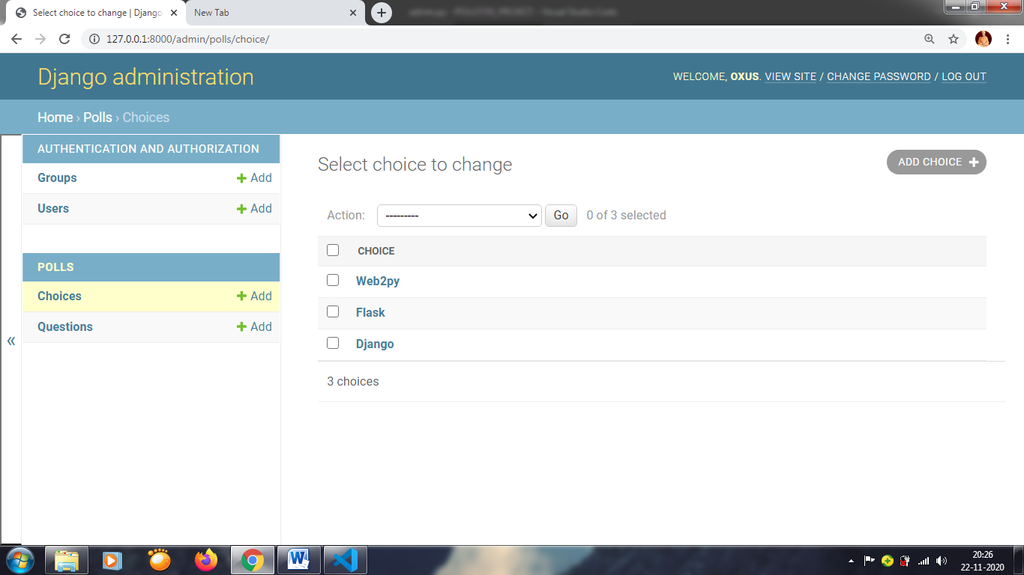

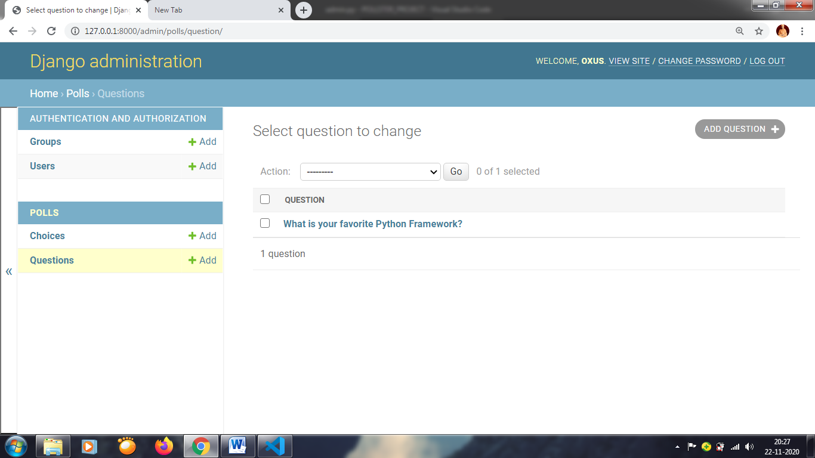 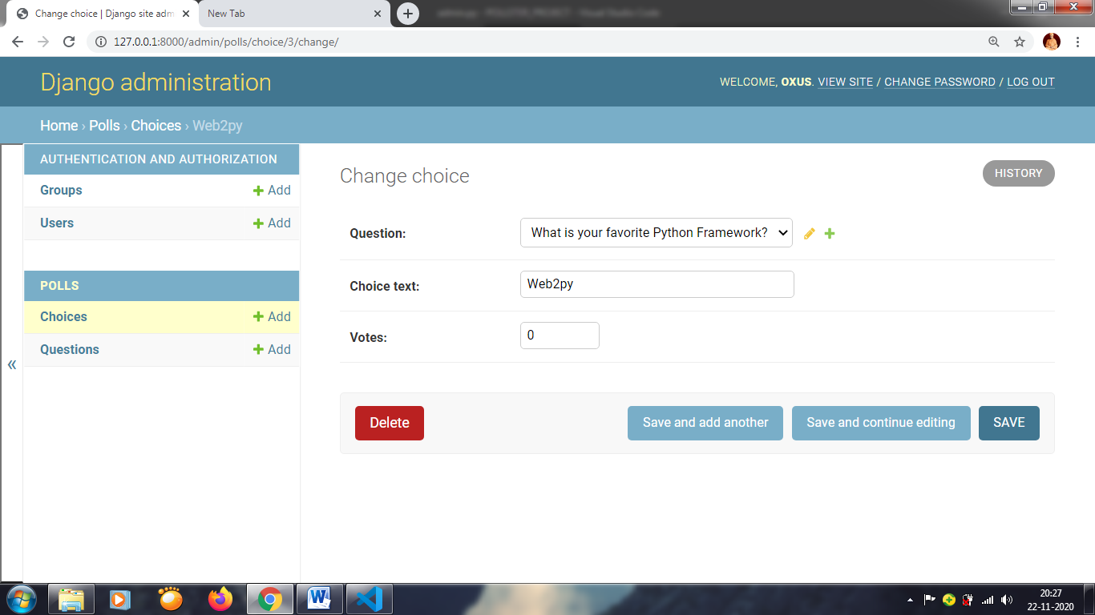

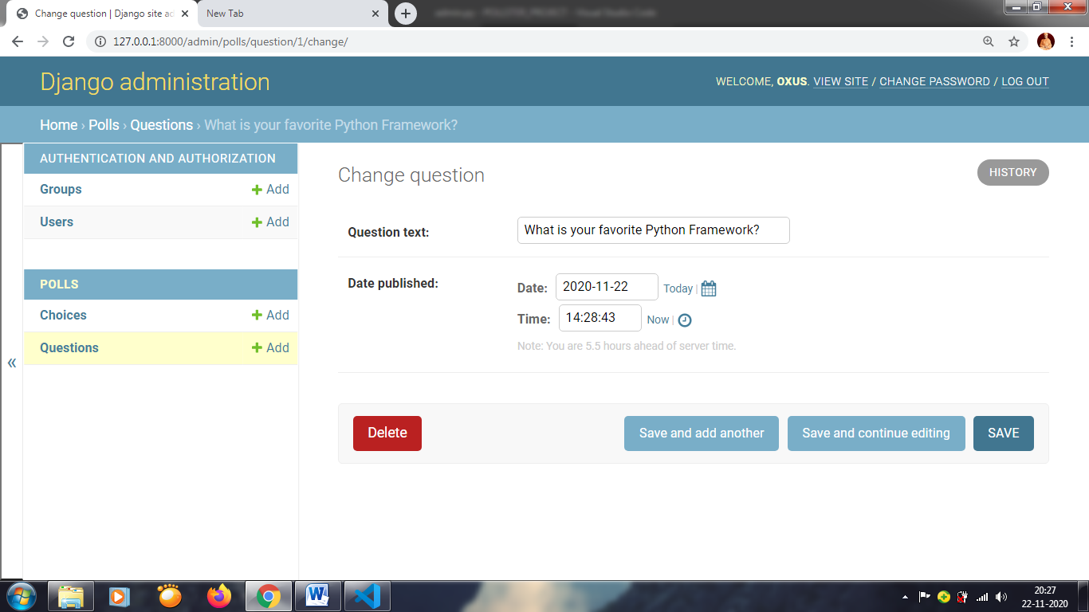

polls/admin.py

**We want have those choices within Question admin screen. We are going to use tabular inline**

from django.contrib import admin

from .models import Question, Choice

class ChoiceInline(admin.TabularInline):

    model = Choice

    extra = 3

class QuestionAdmin(admin.ModelAdmin):

    fieldsets = [(None, {'fields': ['question_text']}), ('Date Information', {'fields': ['pub_date'], 'classes': ['collapse']}), ]

    inlines = [ChoiceInline]

admin.site.register(Question, QuestionAdmin)

[**http://127.0.0.1:8000/admin/**](http://127.0.0.1:8000/admin/)

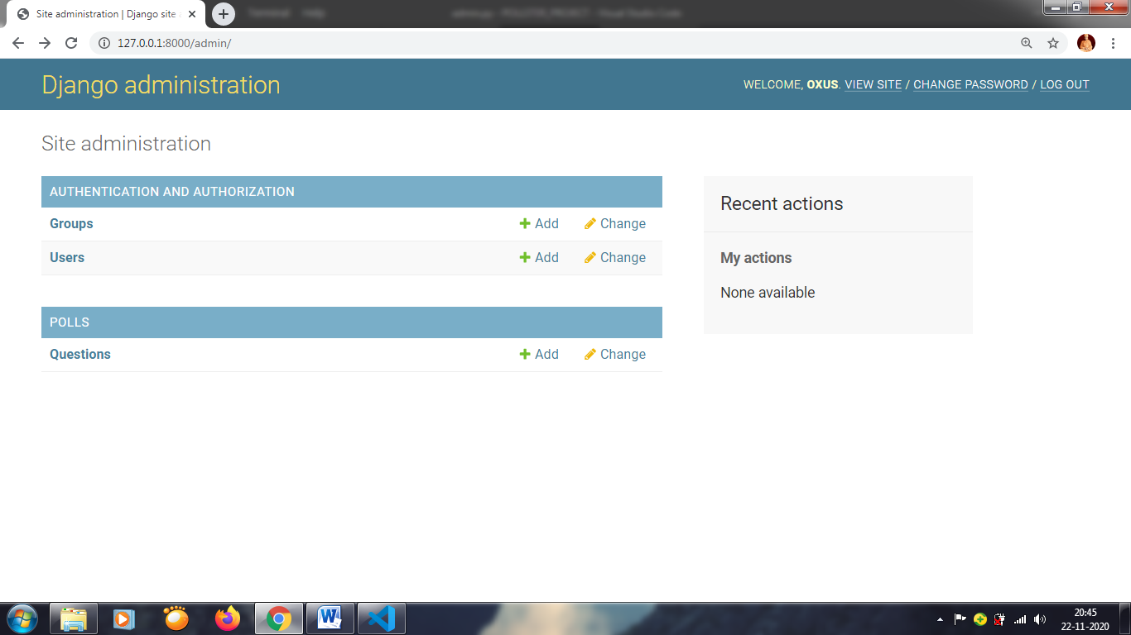 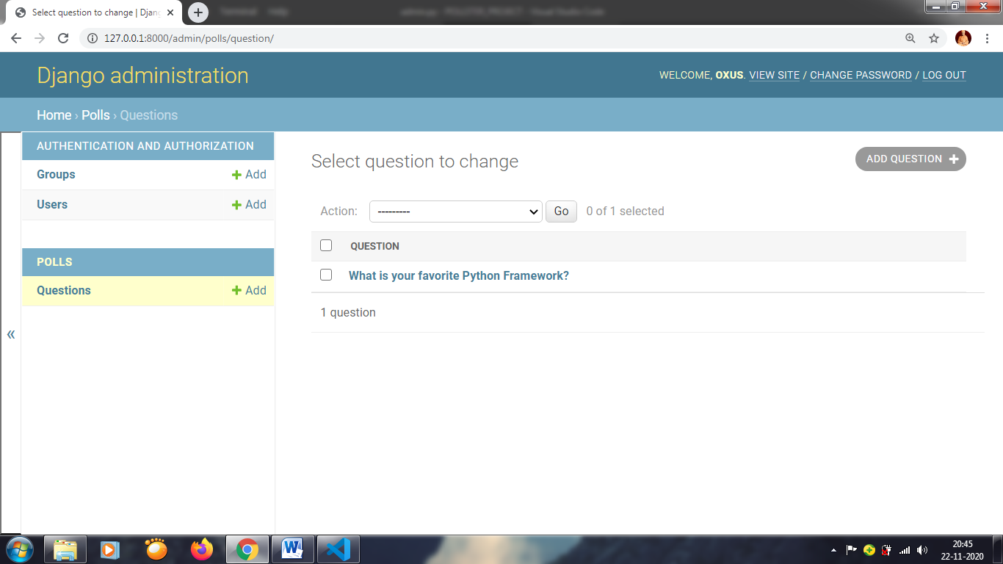 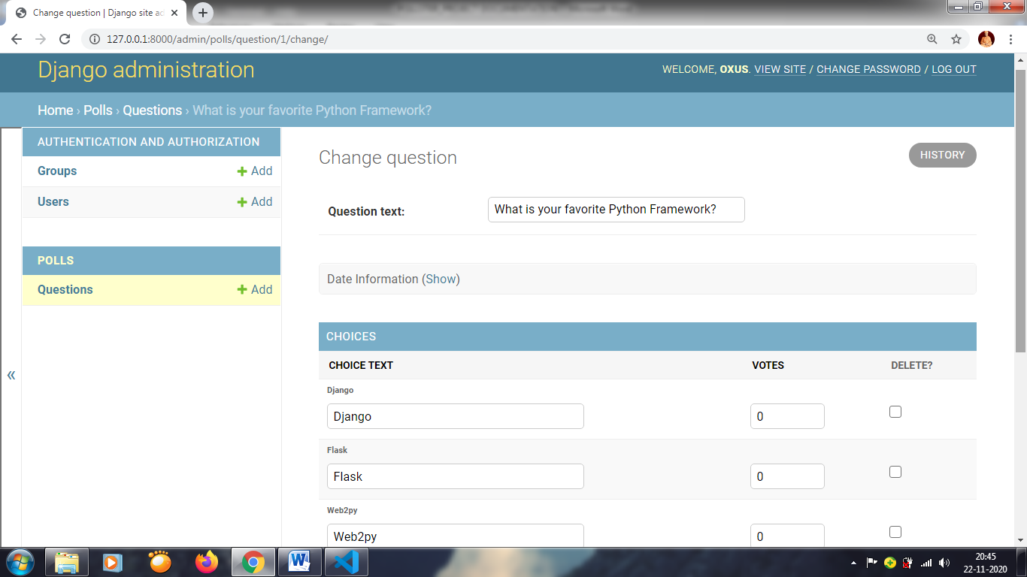

**pollster/urls.py**

from django.contrib import admin

from django.urls import path, include

urlpatterns = [

    path('admin/', admin.site.urls),

    path('polls/', include('polls.urls'))

]

**polls/urls.py**

from django.urls import path

from . import views

app_name = 'polls'

urlpatterns = [

    path('',views.index, name='index')

]

**polls/views.py**

from django.shortcuts import render

from .models import Question, Choice

# Get qusetions and display them

def index(request):

    return render(request, 'polls/index.html')

**G:\POLLSTER_PROJECT\pollster>mkdir templates**

**Create index.html file inside templates**

**templates/index.html**

**pollster/settings.py**

import os

TEMPLATES = [

    {

        'DIRS': [os.path.join(BASE_DIR, 'templates')],

    },

]